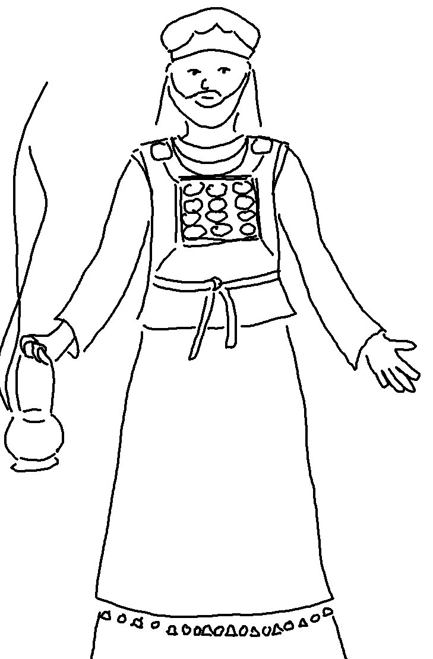
There is a way that seems right to a man but in the end it leads to death.
Proverbs 14:12

